**SPRING MVC TUTORIAL**

* In Spring Web MVC, **DispatcherServlet** class works as the front controller. It is responsible to manage the flow of the spring mvc application.
* The **@Controller** annotation is used to mark the class as the controller in Spring 3.
* The **@RequestMapping** annotation is used to map the request url. It is applied on the method.

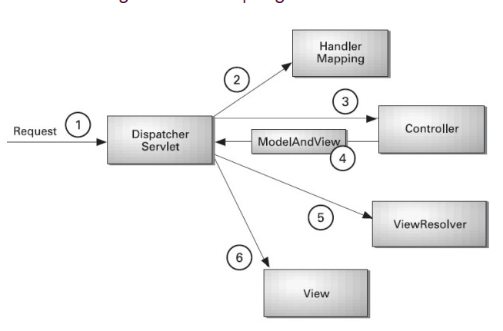

Handler Mapping

Define how web request (URL) maps to the Controller handlers.

* [BeanNameUrlHandlerMapping example](http://www.mkyong.com/spring-mvc/spring-mvc-beannameurlhandlermapping-example/)  
  In Spring MVC, **BeanNameUrlHandlerMapping** is the default handler mapping mechanism, which maps **URL requests to the name of the beans**

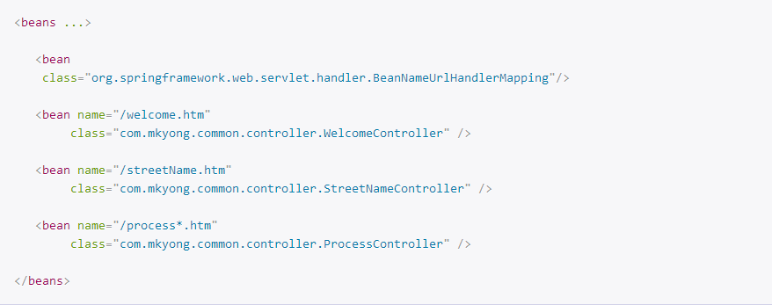

* Whatever URI will be received in the request, the dispatcherservlet will accordingly send the request to the respective controller.
* [ControllerClassNameHandlerMapping example](http://www.mkyong.com/spring-mvc/spring-mvc-controllerclassnamehandlermapping-example/)
* In Spring MVC, **ControllerClassNameHandlerMapping** use convention to map requested URL to Controller (convention over configuration). It takes the Class name, remove the ‘Controller’ suffix if exists and return the remaining text, lower-cased and with a leading “/”.

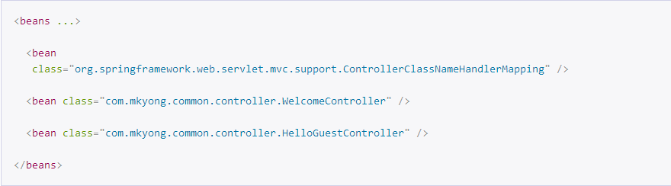

1. /welcome.htm –> WelcomeController.
2. /welcomeHome.htm –> WelcomeController.
3. /helloguest.htm –> HelloGuestController.
4. /helloguest12345.htm –> HelloGuestController.
5. /helloGuest.htm, failed to map **/helloguest\***, the “g” case is not match.

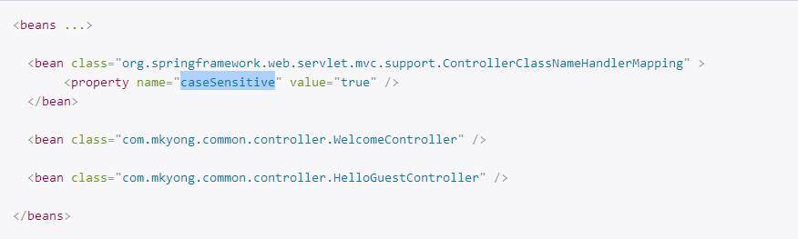

WelcomeController -> /welcome*

HelloGuestController -> /helloGuest*

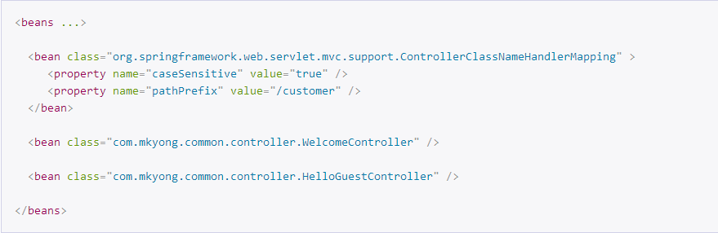



* [SimpleUrlHandlerMapping example](http://www.mkyong.com/spring-mvc/spring-mvc-simpleurlhandlermapping-example/)  
  In Spring MVC application, the **SimpleUrlHandlerMapping** is the most flexible handler mapping class, which allows developer to specify the mapping of URL pattern and handlers explicitly.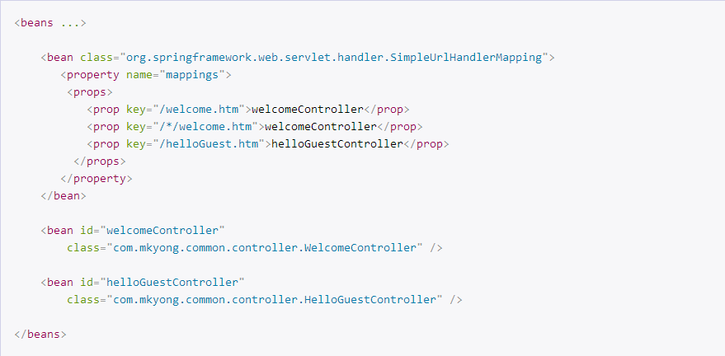

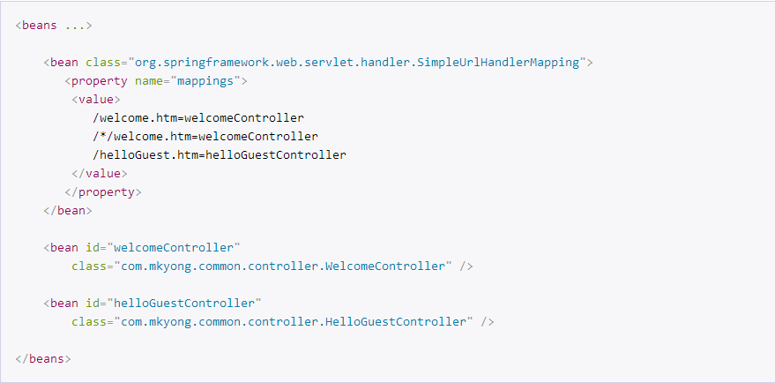

* [Configure the handler mapping priority](http://www.mkyong.com/spring-mvc/configure-the-handler-mapping-priority-in-spring-mvc/)  
  If multiple view handler mappings are applied, you have to declare priority to avoid conflict issue.

